**Adding a new “records” variable and “policy” variable in PIT Microsimulation**

1. Variables used in tax functions and the calculator are either
   1. “policy” variables that are declared in current_law_policy.json or,
   2. “record” variables that are inputs from the tax return (or survey data) or calculated variables that need to be declared in records_variables.json. They are either
      1. “read” variables or,
      2. “calculated” variables.
2. In the tax functions example below,

|  |
| --- |
| @iterate_jit(nopython=True)  def calc_income_house_property(HP_deduction, INCOME_HP, Income_House_Property):  Income_House_Property = INCOME_HP - HP_deduction  return Income_House_Property |

The variables “INCOME_HP” is obtained from the Tax Return (or Survey) and hence is a “records” variable

“HP_deduction” is a policy variable

“Income_House_Property” is a calculated variable which reflects the income from House Property after Deduction and is included as a “records” variable

Note: Even though “Income_House_Property” is returned by the function, it is declared as an input at the function definition

1. Declare the variables in the respective json files.

“INCOME_HP” and “Income_House_Property” are declared in records_variable.json. “INCOME_HP” is declared as a “read” variable as it is directly read from the tax return/survey while “Income_House_Property” is declared as a “calc” (calculated) variable.

|  |  |
| --- | --- |
|  |  |

“HP_deduction” is a policy variable and is declared in current_law_policy.json.

|  |
| --- |
|  |

1. Next, “read” variables are likely to grow with time and hence we need to incorporate their growth in “growfactors” files and functions. In case the variable is not included in growfactors it is understood that that variable grows with the CPI. Nothing needs to be done in such a case.
2. In case we want the variable “INCOME_HP” to grow at a certain defined rate, we first update “growfactors.csv” putting the growth rate of the variable “GF_INCOME_HP”.

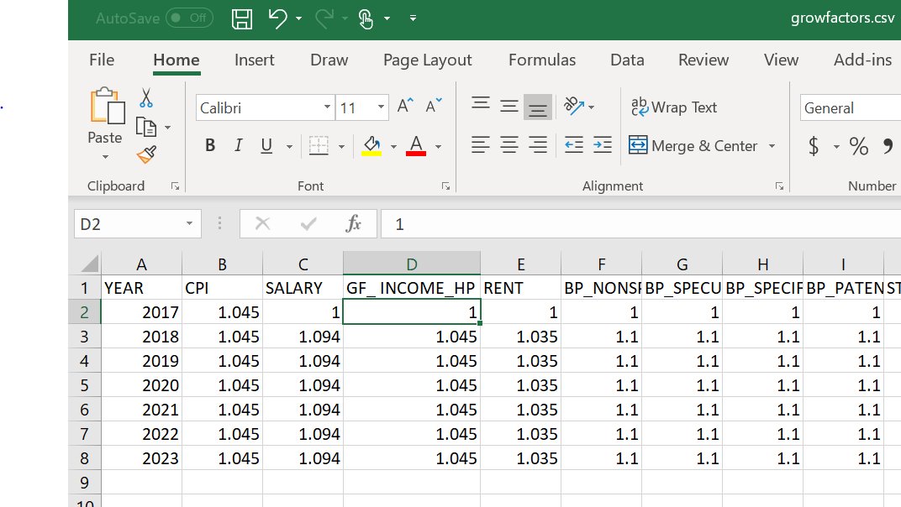

1. We now need to “blow up” the INCOME_HP by this growfactor “GF_INCOME_HP” every year so we update growfactors.py
2. We then include the variable “GF_INCOME_HP” as a “VALID_NAME” in the “GrowFactors” Class.

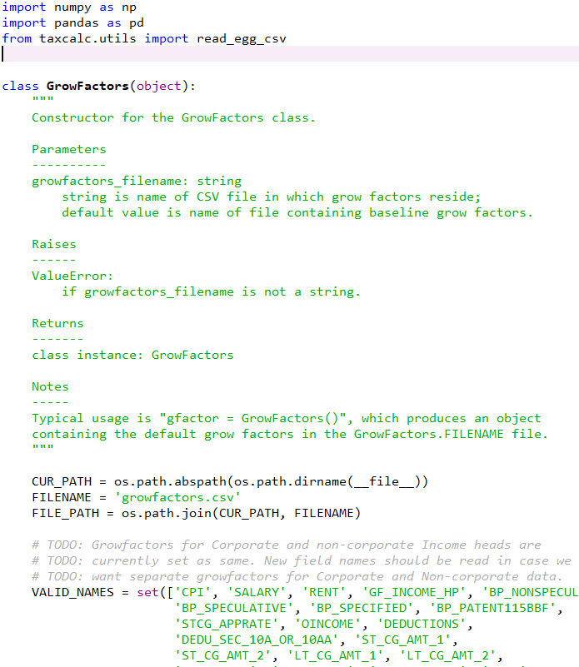

1. Finally, we need to update the records each year at the respective growth rates. This is done in records.py in the _blowup function.
2. First “import” the variable “GF_INCOME_HP” from the growfactors.csv file (in the example below we use the same name but this need not be the case). We then update the INCOME_HP with INCOME_HP*GF_INCOME_HP.

